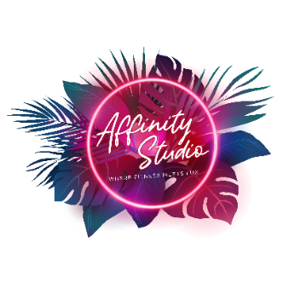
COVID-19 Waiver and Policy
Affinity Studio requires proof of vaccination in order to participate in classes without a mask. We keep a copy on file to ensure safety of all our participants. If you are NOT vaccinated, you must wear a mask in the studio at all times. No exceptions will be made. Please email a copy of your vaccination card ASAP to info@affinitystudioct.com. Participation in class without a mask will not be allowed until we receive a copy. Thank you for your cooperation!
To prevent the spread of COVID-19 and reduce the potential risk of exposure to our workforce and visitors, we are conducting a simple screening questionnaire. Your participation is important and required to help us take precautionary measures to protect you and everyone in this building. Thank you for your time, consideration, and truthful responses.
- You agree to NOT attend class if you cared for someone diagnosed with COVID-19 within the 14 days.
Initial here: __________

- You agree NOT to attend class if you experienced any cold or flu-like symptoms within 14 days.
Initial here: __________

- You agree to wear a mask at ALL times you are in Affinity Studio.
Initial here: __________
By signing this agreement, I acknowledge the contagious nature of COVID-19 and voluntarily assume the risk that I may be exposed to or infected by COVID-19 by my mere presence within this establishment and that such exposure or infection may result in personal injury, illness, permanent disability, and death. I understand that the risk of becoming exposed to or infected by COVID-19 may result from the actions, omissions, or negligence of myself and others, including, but not limited to, employees, volunteers, and program participants and their families. I hereby release the booked business from any and all claims arising from or in connection with any direct COVID-19 impact while visiting.

Signature: _________________________________________________________________
Print Name:
Date:

