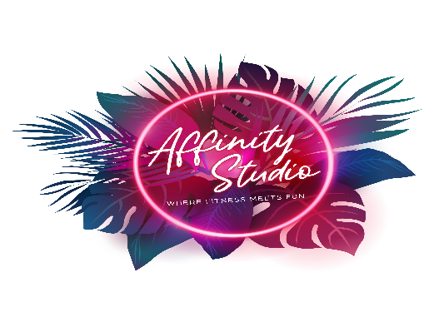

**Photograph and Video Waiver Release Form**

Purpose:  Affinity Studio LLC of 10 Roberts Lane, Suite 5, Ridgefield, Connecticut.06877, their photographers/filmmakers, marketing agencies, affiliates, subsidiaries, successors, employees, agents, representatives and assigns (collectively “Released Party”)  
  
Assignment: For good and valuable consideration, the receipt of which is acknowledged by signing this release, I, the undersigned and a member of the group known as Group Fitness Participants that is releasing its rights to Released Party, hereby convey, transfer and assign all right, title and interest to Released Party in and to any images, text, quotes, comments, endorsements, videos, likeness, film, audio, audio-visual, graphic or verbal depictions of any kind of me knowingly provided by me to Released Party or taken of me by Released Party (the “Content”).  
  
The Content, including the copyright and all other rights therein, shall be Released Party’s sole and exclusive property and I hereby grant and assign all rights of any nature in and to the Content. I waive the exercise of any “moral rights” and “droit moral” and any analogous rights however denominated in any jurisdiction of the world. Released Party’s rights include the right to authorize, prohibit and control the renting, lending, fixation, reproduction or other exploitation of the Content by any media and means now known or hereafter devised as may be conferred upon Released Party under applicable laws, regulations or directives, including without limitation, any so-called rental and lending rights pursuant to any European Union (“EU”) directives or any enabling or implementing legislation, laws or regulations enacted by the member nations of the EU. I agree that the Content may be combined with other images, text, graphics, and film audio and audio-visual works; and may be cropped, altered or modified. Released Party is not obligated to use the Content.    
  
I agree that I have no rights to the Content, and I also have no right to any of Released Party’s trademarks, copyrighted materials and other intellectual property. I waive any right to inspect or approve the finished version(s) of any reproduction of the Content. I acknowledge and agree that I will make no further claim for any reason to or against Assignees.  
  
I reasonably believe that what I say or provide to you so that you can create the Content is true, and free of libel, obscenity, and other unlawful matter, and does not infringe the intellectual property or privacy rights of any other individual or entity. I acknowledge and agree that I have no further right to additional consideration or accounting, and that I will make no further claim for any reason to the Released Party.  I also hereby release the Released Party from all claims, demands, and liabilities whatsoever in connection with the above.  I agree that this release is irrevocable, worldwide and perpetual, and will be governed by the laws of the State of Connecticut. The exclusive venue for any dispute shall be a court of competent jurisdiction in the State of Connecticut.

2. I represent and warrant that I am at least 18 years of age and have full legal capacity to execute this release. *PLEASE CHECK NO IF YOU DO NOT WISH FOR YOUR PHOTO TO BE USED.

* Yes



* No



I acknowledge that I have completely read and fully understand the above release and fully agree to be bound thereby.

X____________________________________ ________________________________

Signature Print Name

Date:_________________________________